Flute

It's a kind of wind music instrument. It has a simple construction and is estimated to be one of the oldest musical instruments in history. The flute can be built in metal or wood

Parts:

The flute has three main parts: the head joint, the body and the foot joint. 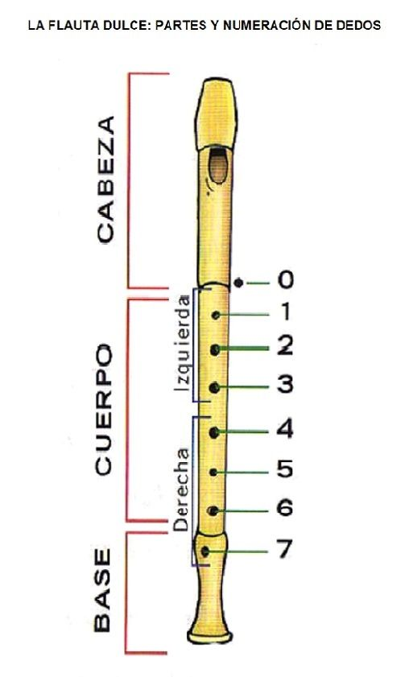

FOOT



HEAD



BODY

